Chassis, cab accessories.
Lighting
(All Models)
Table of Contents

Brake light switch ............................................... 9A-2
Removing ................................................ ... 9A-2
Monitoring ............................................ 9A-3.
Installation ............................................... .. 9A-4
Bearing ............................................... ..... 9A-5
Removing ................................................ ... 9A-5
Monitoring ............................................ 9A-6.
Installation ............................................... .. 9A-8
Fog Lamps ......................................... 9A-9
Removing ................................................ ... 9A-9
Monitoring ............................................ 9A-10.
Installation ............................................... .. 9A-11
Side turn signal lamp. ........................ 9A-12
Removing ................................................ ... 9A-12
Installation ............................................... .. 9A-13
Switch Total ............................................... .. 9A-14
Monitoring ............................................ 9A-14.
Switch door ............................................. ...... 9A-19
Removing ................................................ ... 9A-19
Monitoring ............................................ 9A-20.
Installation ............................................... .. 9A-21
Halogen Headlight Bulbs ................................... 9A-22
Removing ................................................ ... 9A-22
Installation ............................................... .. 9A-23
Lamp dimmer ............................................... ... 9A-24
Removing ................................................ ... 9A-24
Installation ............................................... .. 9A-25
The rear brake lights ................................... 9A-26
Removing ................................................ ... 9A-26
Installation ............................................... .. 9A-27
Plate light bulbs ............................... 9A-28
Removing ................................................ ... 9A-28
Installation ............................................... .. 9A-29
Switch door ............................................. ...... 9A-19
Removing ................................................ ... 9A-19
Monitoring ............................................ 9A-20.
Installation ............................................... .. 9A-21
Halogen Headlight Bulbs ................................... 9A-22
Removing ................................................ ... 9A-22
Installation ............................................... .. 9A-23
Lamp dimmer ............................................... ... 9A-24
Removing ................................................ ... 9A-24
Installation ............................................... .. 9A-25
The rear brake lights ................................... 9A-26
Removing ................................................ ... 9A-26
Installation ............................................... .. 9A-27
Plate light bulbs ............................... 9A-28
Removing ................................................ ... 9A-28
Installation ............................................... .. 9A-29
Monitoring ............................................... 9A-36
Installation ............................................... ..... 9A-37
Projector Lamp High ................................... 9A-39.
Removing ................................................ ...... 9A-39
Installation ............................................... ..... 9A-40
Low light projection lamp. Lahore ............................................ 9A-41
Removing ................................................ ...... 9A-41
Installation ............................................... ..... 9A-42
Front turn lamps ...................................... 9A-43
Removing ................................................ ...... 9A-43
Installation ............................................... ..... 9A-44
Map reading lamp .......................................... 9A-45
Removing ................................................ ...... 9A-45
Installation ............................................... ..... 9A-46
The third brake light unit ............................................... 9A-47
Removing ................................................ ...... 9A-47
Installation ............................................... ..... 9A-48

9A - 2 lighting system (all models).
Brake Light Switch
removal
1. Disconnect the battery ground cable.
1. Disconnect the battery from the battery ground.
2. Remove the brake light switch
1. Remove the brake light switch from the brake pedal bracket.
2. Unplug the power cord bundle from the brake light switch.
3. Loosen the lock nut wrench
Note:
· Turn the switch off and set off from the main bracket.
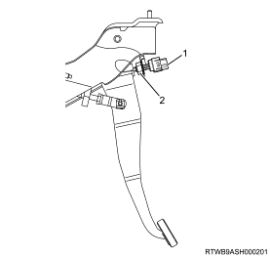
1. Brake Light Switch
2. Lock nut

Lighting system (Models) 9A - 3
Examination
1. Check the brake light switch.
1. Check the brake light switch Using the test cycle
Note:
· Use the switch to check on the fire between.
polarities
· Confirmation on the fire When the switch is pressed down
· If a fault is detected by the monitoring results.
Change related parts

9A - 4 lighting system (all models).

Installation
1. Install the brake light switch.
1. Install the brake light switch bracket on the brake pedal.
Note:
· Tighten the brake light switch until the end of the spiral.
To tap the brake pedal
CAUTION:
· Be careful not to press with the end of switch.
Note:
· Turn the power switch to verify brake Half gap (L).
And the ends of the keyboard The Spiral 0.2
- 1.2 mm. (0.008 to 0.047 inches) and tighten the lock nut.
· Plug
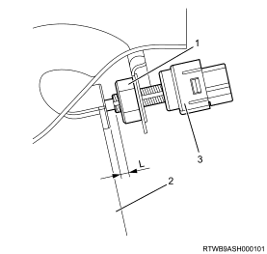

1. Lock nut
2. The brake pedal
3. brake light switch
2. Connect the grounding of the battery.
1. Connect the battery to the battery ground.

Lighting system (Models) 9A - 5.
removal
1. Disconnect the battery ground cable.
1. Disconnect the battery from the battery ground.
2. Remove the grille
1. Remove the grille out of the car.
Note:
· Remove the screws 4.
· Remove the four clips
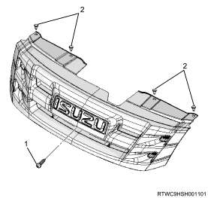
1. Screw
2. clip
3. Remove the front bumper
1. Remove the front bumper of the car.
Note:
· Remove the clip 10
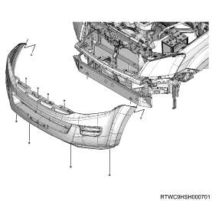
4. Remove the headlight
1. Remove the headlight from the vehicle.
Note:
· Remove the screws 4.
2. Unplug the set of headlights off.
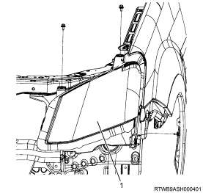
1. Cleaner

9A - 6 lighting system (all models).
Examination
1. Adjust Bearing
1. Check headlights Experiments with light
note:
· After checking the headlight using the tool.
Check headlights The port tuning
· Alignment beam After adjustments to Dock
The height of the control to adjust.
automatic
· Check the tire pressure and impurities headlight lens.
· The condition of the car On the same visit
investigate
· Shine a midpoint (The center lamp)
(A) and (B) of the left and right headlight.
On the scene and draw a vertical line.
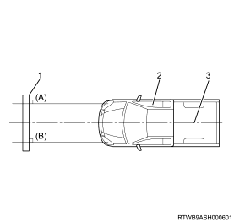
1. Screen
2. car
3. middle line
note:
· Parking trust between 1 meter (3.28 feet) from the grill.
· Draw a line on the scene at the same height.
Center of power
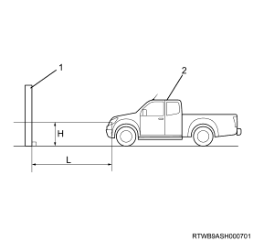
1. Screen
2. car
note:
· Turn on the headlights and the headlight to the lower light.
· Turn off the lights more. It was not fine with black cloth.
· The position of the turning point, with vertical adjustment.
Landscape and define the boundaries of the light.
And the dark horizontal lines of equal value.
The following table of vertical adjustment.
 | The position of point  Refract | Left / right  Alignment turning point
The height of less than  1 meter (3.28 feet) | L = 12 mm.  (0.47in) | 0

Lighting system (Models) 9A - 7.
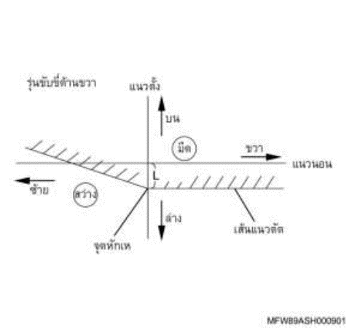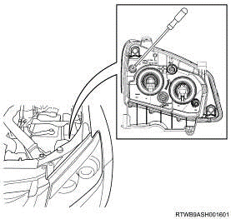
note:
· The vertical adjustment
Turn the screw by using a screwdriver to adjust direction.
Vertical alignment beam
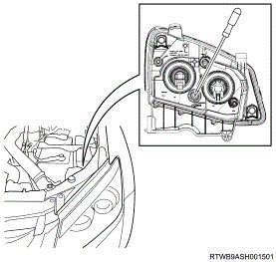
note:
· Horizontal adjustment
Turn the screw by using a screwdriver to adjust direction.
The horizontal orientation of the beam

9A8 lighting system (all models).
installation
1. Install the headlight.
1. Install the light-duty vehicle.
note:
· Install clips of headlights.
Install the plug on another. If motor function
adjust
· Attach the headlights with the four bolts.
Torque: 8 Nm - m {0.8 kg - m / 71 LB - inch}
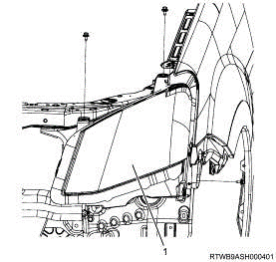
1. Cleaner

2. Install the front bumper.
1. Install the front bumper to the vehicle.
note:
· Install the 10 clips
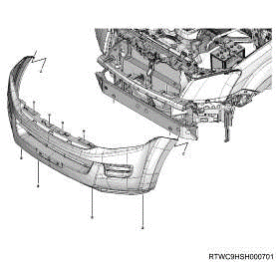
3. To install the grille
1. Install the front grille to the vehicle.
note:
· Put the hooks of the grille into the slot of the bumper.
Page, as shown in the diagram
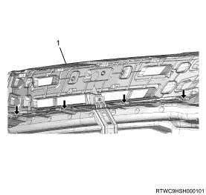
1. Grille

note:
· Install Clip 4
· Installation screws
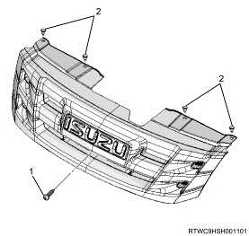
1. Screw
2. clip

4. Connect the ground of the battery.
1. Connect the battery to the battery ground.
note:
· Make sure the lighting.

Lighting system (Models) 9A - 9.
removal
1. Disconnect the battery ground cable.
1. Disconnect the battery from the battery ground.
2. Remove the grille
1. Remove the grille out of the car.
note:
· Remove the screws 4.
· Remove the four clips
1. Screw
2. clip

3. Remove the front bumper
1. Remove the front bumper of the car.
note:
· Remove the clip 10
4. Removing the fog light.
1. Remove the fog lamp out of the fog lights.
Warning:
· Do not use the handles on the glass of the bulb cut.
direct fog
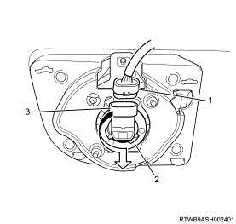
1. Plug
2. fog lights
3. Fog Lamps

9A - 10 lighting system (all models).
Examination
1. Adjust the fog light.
note:
· Port customized vertical direction.
Turn the screw by using a screwdriver. And fog lights
In the vertical direction
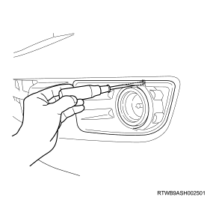

Lighting system (Models) 9A - 11.
installation
1. Install the fog lamp.
1. Install the fog lamp with fog lamp.
2. Install the plug on the power cord to bind fog lights.
1. Plug the power cable bundle
2. fog lights
3. Fog Lamps
2. Install the front bumper.
1. Install the front bumper to the vehicle.
note:
· Install the 10 clips
3. To install the grille
1. Install the front grille to the vehicle.
note:
· Put the hooks of the grille into the slot of the bumper.
Page, as shown in the diagram
1. Grille

note:
· Install Clip 4
· Contact the screw
1. Screw
2. clip

4. Connect the ground of the battery.
1. Connect the battery to the battery ground.
note:
· Make sure the lighting.

9A - 12 lighting system (all models).
Side turn signal lamp.
removal
1. Disconnect the battery ground cable.
1. Disconnect the battery from the battery ground.
2. Remove the side turn signal lamp.
1. Remove the side turn lamp from the lamp socket.
note:
· Turn the lamp socket, turn to the side to detach.
And remove the bulb from the socket.
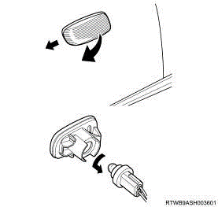

Lighting system (Models) 9A - 13.
installation
1. Install the side turn signal lamp.
1. Install the side turn signal lamp bulb into the socket.
note:
· Install the lamp into the lamp socket. And installing the Bao
Turn the lamp side by rotation.
2. Install the light side.
1. Install the side turn signal lights to the set goal.
3. Connect the ground of the battery.
1. Connect the battery to the battery ground.
note:
· Make sure the lighting.

9A - 14 lighting system (all models).
The series switches include
Examination
1. Check the switch as well.
1. Check the switch included Using the test cycle
note:
· Use the switch to check on the fire.
Between polarities
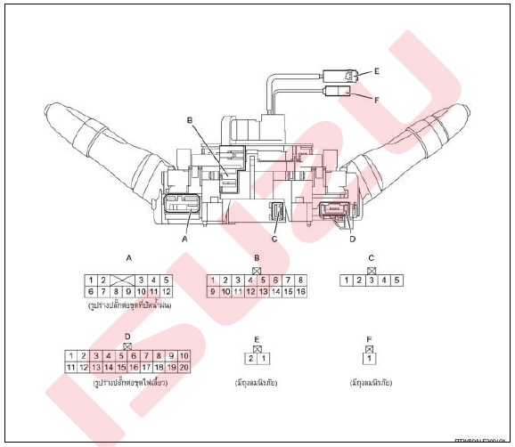
note :
· INT (plug A).

Lighting system (Models) 9A - 15.
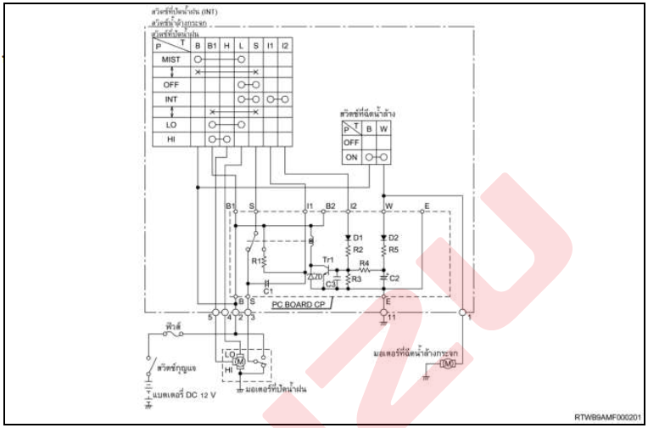

9A - 16 lighting system (all models).
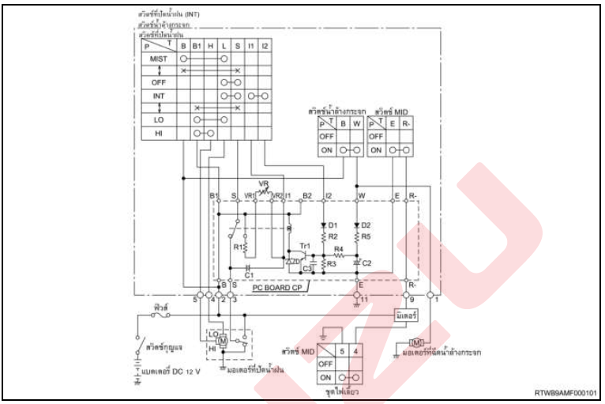
note:
· plug connector A

Lighting system (Models) 9A - 17.
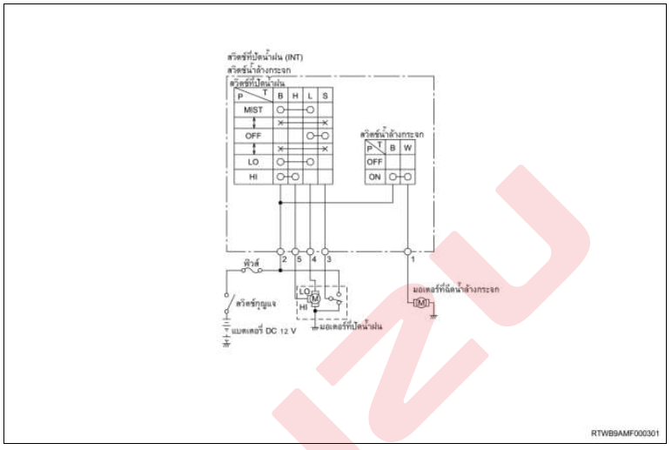
note:
· Plug-D

9A - 18 lighting system (all models).
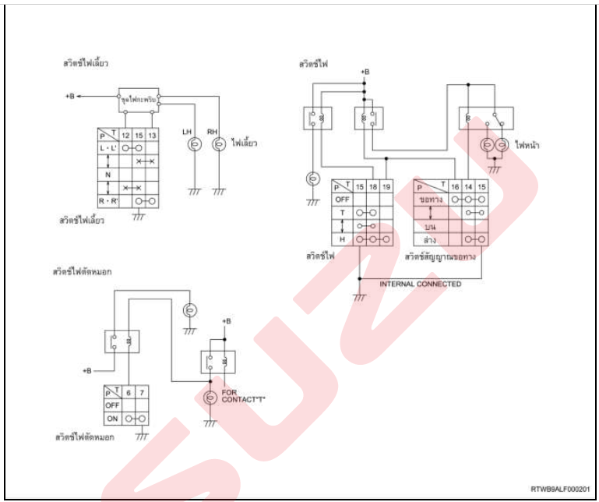

Lighting system (Models) 9A - 19.
door switch
removal
1. Disconnect the battery ground cable.
1. Disconnect the battery from the battery ground.
2. Remove the door switch
1. Remove the door switch off the car.
note:
· Use a flat-blade screwdriver to open the cover and remove the screw.
· Pull out the door switch Then unplug the power cable bundle.
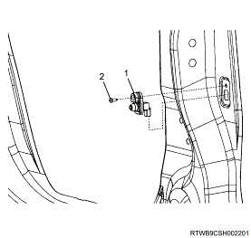
1. Switch door
2. Screw

9A - 20 lighting system (all models).
Examination
1. Check door switch
1. Check door switch Using the test cycle
note:
· Use the switch to check on the fire.
Between polarities
The function of the switch | terminals (1) | Ground
When pressed | - | -
When released | O | O

note:
· Confirmation on the fire When the switch is pressed down
· If a fault is detected by the monitoring results.
Change related parts

???HERE??? – 9A-21 next

Chassis, cab accessories.
Rain water system, windshield, the windshield washer.
(All Models)
Table of Contents

Wipers .............................................. .. 9B-2
Removing ................................................ ... 9B-2
Installation ............................................... .. 9B-3
Rubber wiper ............................................. 9B-4
Removing ................................................ ... 9B-4
Installation ............................................... .. 9B-5
Motor spraying washer ........................... 9B-6
Removing ................................................ ... 9B-6
Monitoring ............................................ 9B-8
Installation ............................................... .. 9B-9
Washer nozzles, water ........................................ 9B-11
Removing ................................................ ... 9B-11
Monitoring ............................................ 9B-12
Installation ............................................... .. 9B-13
Motor oil, windshield rain ..................................... 9B-14
Removing ................................................ ... 9B-14
Installation ............................................... .. 9B-15
Linkage to ward off rain water ...................................... 9B-16
Removing ................................................ ... 9B-16
Installation ............................................... .. 9B-17
Chassis, cab accessories.
Control systems, electrical systems, facilitate.
(All Models)
Table of Contents

Cigarette packs 9C-2.
Removing 9C-2
Installation 9C-3
Speaker gate 9C-4.
Removing 9C-4
Monitoring 9C-6
Installation 9C-7
Antenna 9C-9
Removing 9C-9
Monitoring 9C-10
Installation 9C-11
9C-12 emergency power switch
Removing 9C-12
Monitoring 9C-13
Installation 9C-14
Radio 9C-15
Removing 9C-15
Installation 9C-16

Switch horn 9C-17.
Removing 9C-17
Monitoring 9C-18
Installation 9C-19
Horn (HIGH) 9C-20.
Removing 9C-20
Monitoring 9C-21
Installation 9C-22
Horn (LOW) 9C-23.
Removing 9C-23
Monitoring 9C-24
Installation 9C-25
The front door power window switch 9C-26.
Removing 9C-26
Monitoring 9C-27
Installation 9C-29
Switch 4WD 9C-30
Removing 9C-30
Monitoring 9C-31
Installation 9C-32
Tweeter 9C-33.
Removing 9C-33
Monitoring 9C-34
Installation 9C-35
Speaker rear door 9C-36.
Removing 9C-36
Monitoring 9C-38
Installation 9C-39
Channel power accessories 9C-41.
Removing 9C-41
Installation 9C-42
DVD CD / DVD 9C-43.
Removing 9C-43
Installation 9C-44
Power window switch 9C-45.
Removing 9C-45
Monitoring 9C-47
Installation 9C-48
Handbrake switch 9C-50
Removing 9C-50
Monitoring 9C-51
Installation 9C-52
Switches key 9C-53
Removing 9C-53
Installation 9C-58
The series switches include 9C-61.
Removing 9C-61
Installation 9C-65
Switch ESC off 9C-67
Removing 9C-67
Monitoring 9C-68
Installation 9C-69
Chassis, cab accessories.
Using the dashboard / data drive (all models).
Table of Contents

Vehicle speed sensors ............................................ 9E-2
Removing ................................................ .............. 9E-2
Monitoring ............................................... ........ 9E-3
Installation ............................................... ............. 9E-4
BCM ................................................. ..................... 5-9E
Removing ................................................ .............. 9E-5
Installation ............................................... ............. 9E-6
Setting ............................................... ............. 9E-7
DRM ................................................. 9E-9 .....................
Removing ................................................ .............. 9E-9
Installation ............................................... ............. 9E-10
The panel ................................................ ............. 9E-11
Removing ................................................ .............. 9E-11
Installation ............................................... ............. 9E-13
Setting ............................................... .............. 9E-14
Receiver Remote unlock system ......................... 9E-17
Removing ................................................ .............. 9E-17
Installation ............................................... ............. 9E-26
Chassis, cab accessories.
Bonnet, mudguards, doors.
(All Models)
Table of Contents

The kit consists of a front door 9G-2.
Removing 9G-2
Dismantling 9G-3.
The reassembly 9G-6
Installation 9G-9
Setting 9G-10
Set hood 9G-11.
Removing 9G-11
Installation 9G-12
STEP 9G-13
Removing 9G-13
Installation 9G-14
Stairs bumper 9G-15
Removing 9G-15
Installation 9G-16
Locking bonnet 9G-18.
Removing 9G-18
Installation 9G-20

Front fender panel 9G-22
Removing 9G-22
Installation 9G-23
Set back door (Cab4) 9G-25.
Removing 9G-25
Dismantling 9G-26.
The reassembly 9G-28
Installation 9G-30
Setting 9G-31
Mudguards front suspension 9G-32.
Removing 9G-32
Installation 9G-33
Panel and side doors (Spacecab) 9G-34.
Removing 9G-34
Dismantling 9G-35.
The reassembly 9G-37
Installation 9G-40
Setting 9G-41
Rear fender 9G-42
Removing 9G-42
Installation 9G-43
Extra Info 9G-44
Chassis, cab accessories.
The Cab
(All Models)
Table of Contents

Grille 9H-2
Removing 9H-2
Installation 9H-3
The front air intake 9H-4.
Removing 9H-4
Installation 9H-5
The valve deflates 9H-6.
Removing 9H-6
Installation 9H-6
Front bumper 9H-7
Removing 9H-7
Installation 9H-9
Extra Info 9H-11

Chassis, cab accessories.
seat
(All Models)
Table of Contents
Rear seat 9I-2
Removing 9I-2
Installation 9I-3
Front seat 9I-4
Removing 9I-4
Installation 9I-7
Extra Info 9I-10

Chassis, cab accessories.
Security Locks
(All Models)
Table of Contents

Key ................................................ ............. 9J-2
To disassemble ......................................... 9J-2
Assembly ................................................ ... 9J-3
Setting ............................................... ........ 9J-4
ICU ................................................. ...................... 9J-6
Removing ................................................ ......... 9J-6
Installation ............................................... ........ 9J-7
Setting ............................................... ........ 9J-8
Control units open inlet fuel ................... 9J-10
Removing ................................................ ......... 9J-10
Installation ............................................... ........ 9J-13
Antitheft horn ............................................... ....... 9J-16
Removing ................................................ ......... 9J-16
Monitoring ............................................... ... 9J-17
Installation ............................................... ........ 9J-18
Extra Info ................................................ .............. 9J-19

Chassis, cab accessories.
Internal and external cover
(All Models)
Table of Contents

Roof 9 L-2
Remove the 9L-2
Installation 9L-9i
The panel 9L-17
Remove the 9L-17
Installation 9L-26
Cover 9L-33
Remove the 9L-33
Installation 9L-40
Console box 9L-47
Remove the 9L-47
Installation 9L-48
Extra Info 9L-49

Chassis, cab accessories.
Sub-frame unit body
(All Models)
Table of Contents

Mount chassis .............................................. ..... 9P-2
Installation ............................................... ..... 9P-2
End caps ................................................ ........... 9P-8
Removing ............................................................ 9P-8
Installation ......................................................... 9P-9.
Utility back ............................................................ 9P-11
Removing ............................................................ 9P-11
Installation ......................................................... 9P-14.
Extra Info ................................................ ...... 9P-17

Chassis, cab accessories.
Glass, windows, mirrors.
(All Models)
Table of Contents

Set rear ............................................... ....... 9T-2
Removing ................................................ .......... 9T-2
Monitoring ............................................... .... 9T-9
Installation ............................................... ......... 9T-11
Windshield ................................................ .......... 9T-20
Removing ................................................ .......... 9T-20
Installation ............................................... ......... 9T-33
Extra Info ................................................ .......... 9T-47

Description chassis, cab accessories.
Data maintenance
(All Models)
Table of Contents

Caution to maintain the chassis, cab, accessories ................................. ......................................... 23B-2
Function, structure, operation of the chassis, cab, equipment .................................. .............................. 23B-3
Preliminary specifications of the chassis, cab, accessories ..................................... ....................................... 23B-23
Guidance in the analysis of the chassis, cab accessories. .................................................. .............. 23B-42

Explain the chassis, cab accessories.
Audit Directors to employees.
(All Models)
For any account
To determine the precise measurements around 23C-2.
Examination 23C-2
Check the accuracy of the speedometer 23C-3.
Examination 23C-3
Description chassis, cab accessories.
Symptoms (all models)
Table of Contents

Light filters trap it does not light even when the water level is higher than the drain trap water filter 23D-3.
Light filtered water trap light, even when the water level in the filter, trapping Natalie 23D-4.
Driving data No display 23D-5.
Low fuel warning light does not light up. Even when the fuel tank is empty 23D-6.
The brake system warning light does not light up. Even the hand brake 23D-8.
The brake system warning light does not go off. Even when you release the parking brake fully 23D-8.
The brake system warning light does not light up. Even when you release the parking brake fully 23D-9.
The brake system warning light illuminates Although oil additives, brake until the specified 23D-10.
Engine oil pressure warning light goes off. Even as the engine warms 23D-11.
The reading from the engine coolant temperature gauge water over the eyes. (Or above) the fact 23D-12.
The display of the engine cooling water temperature gauges unchanged 23D-13.
The display of the fuel gauge does not address the "f", even when the fuel tank is full 23D-14.
The display of the fuel gauge (up to the "f"), even when the fuel tank is not full 23D-15.
Fuel warning light eyes light up Even when the fuel tank is full 23D-16.
The speedometer needle pointing shaking 23D-17.
An error in the display of the speedometer of the vehicle 23D-18.
The speedometer needle pointing shaking 23D-19.
An error in the display of a large round gauges 23D-20.
The display of the fuel gauge does not alter 23D-21.
Brush motors do not stop working 23D-22.
Motor spraying the washer does not work 23D-23.
Speedometer car And the odometer does not work 23D-24.
No odometer records the distance traveled. (Speedometer car in normal condition 23D-25.
Car speedometer does not work. (Odometer in normal condition) 23D-26.
The right rear window does not work 23D-27.
Rear left is not working 23D-28.
I brushed the rain that does not work, switch to the position wherever 23D-29.
The rain did not stop working on my batting position "INT" 23D-30.
The rain did not stop working on my batting position "LO" 23D-31.
The rain did not stop working on my batting position "HI" 23D-32.
All the mirrors do not work 23D-33.
Driver's side mirror was not working 23D-34.
Glass Front left no work 23D-35.
Rear both sides are working 23D-36.
Irregularities in the operation of the fire in the hood 23D-37.
Irregularities in the operation of the brake lights / taillights 23D-38.
Irregularities in the operation of plate light 23D-39.
Irregularities in the operation of lighting, no set of measurements 23D-40.
Irregularities in the operation of the light gauge set 23D-41.
Irregularities in the operation of the reversing light 23D-44.
Irregularities in the operation of headlights 23D-45.
Irregularities in the operation of the lamp 23D-46.
Irregularities in the functioning of the fog lights 23D-47.
Irregularities in the operation of the lamp 23D-48.

